
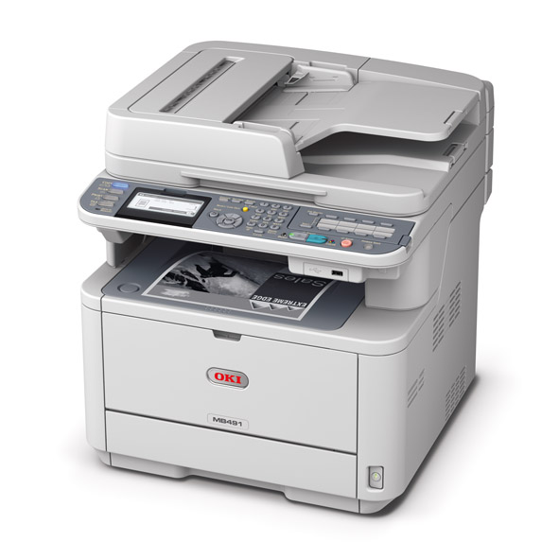
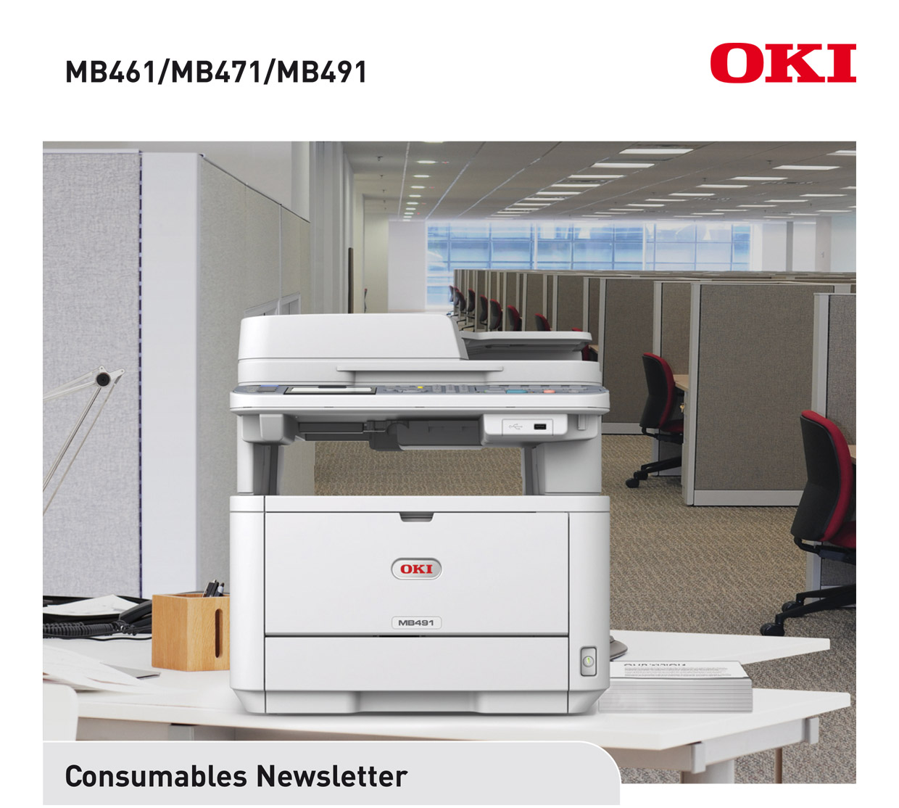
DATE: March 2012
ISSUED BY: Jane Mannering (jane.mannering@okieurope.com)
SUBJECT: MB461/MB471/MB491 Consumables

A4 mono | 
Duplex print, copy, scan for MB461  Duplex print, copy, scan, fax for MB471/MB491 | 
Range of media handling | 
Print speed of up to 33ppm for MB461/MB471  and 40ppm for MB491 | 
1 to 20+ users for the MB491 | 


© 2012 Oki Europe Ltd. Version 1.0 3.2012.
OKI EUROPE LTD.
Blays House, Wick Road
Egham TW20 0HJ
United Kingdom
T +44(0) 20 8219 2190
F +44(0) 20 8219 2199
WWW.OKIPRINTINGSOLUTIONS.COM

MB461/MB471/MB491
Product | Standard Capacity Toner † | Medium Capacity Toner † | High Capacity Toner † | Image Drum
Available From | April 2012 | April 2012 | April 2012 | April 2012
Order Code | 44574702 | 44574802 | 44917602 | 44574302
EAN Code | 5031713048688 | 5031713048701 | 5031713054641 | 5031713048671
Pallet Quantity | 330 | 330 | 330 | 36
Minimum Order Quantity | 1 | 1 | 1 | 1
Yield | 3,000 pages * | 7,000 pages * | 12,000 pages * | 25,000 pages **
New or Existing Product | existing | new | new | existing
Compatible With | B411/B431/ MB461/MB471/MB491 | B431/  MB461/MB471/MB491 | B431/MB491 | B411/B431/ MB461/MB471/MB491
Weight Kg  (box & consumable) | 0.360 | 0.480 | 0.600 | 1.600
Dimensions in mm of packaging w x d x h | 300 x 80 x 93 | 300 x 80 x 93 | 300 x 80 x 93 | 391 x 258 x 236

NOTE: Due to the introduction of the new 7,000 and 12,000 page capacity toners, the existing 10,000 page toner for the
B431 (order code 44574902) will be end of lifed.

* Yield compliant with ISO/IEC 19752
** Average life A4 based on a typical office environment
† For the protection of your product, and in order to ensure that you benefit from its full functionality, this
model has been designed to operate only with genuine Oki Printing Solutions toner cartridges. These can
be identified by the Oki trademark. Any other toner cartridge may not operate at all, even if it is described
as “compatible”, and if it does work, your product's performance and print quality may be degraded.

